<https://www.youtube.com/watch?v=0N0HgHFc98A&list=PL-g0fdC5RMboo-XNa2DzFvYg_9QWBIos6&index=19&ab_channel=%E5%BD%AD%E5%BD%AD%E7%9A%84%E8%AA%B2%E7%A8%8B>

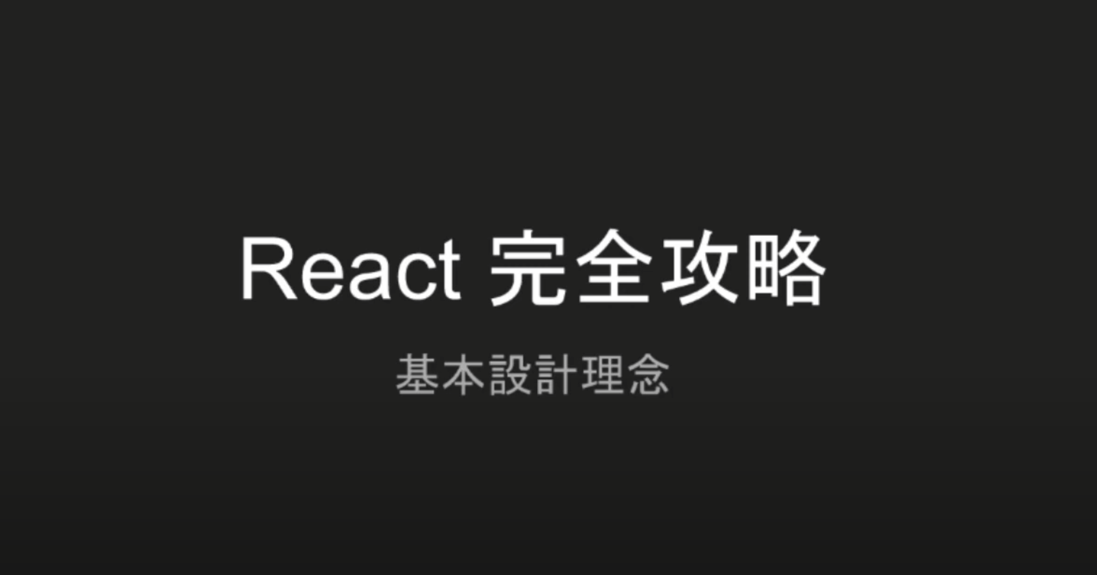

白色的部分叫做ROOT DOM Element

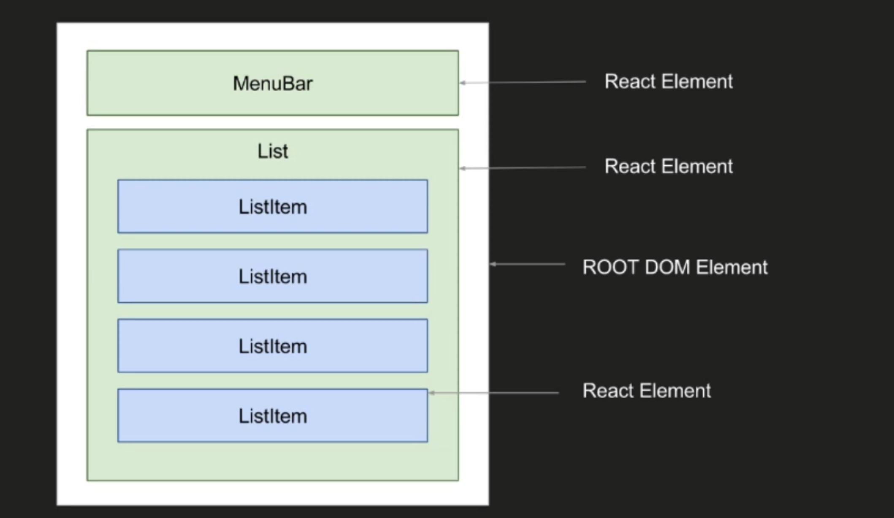

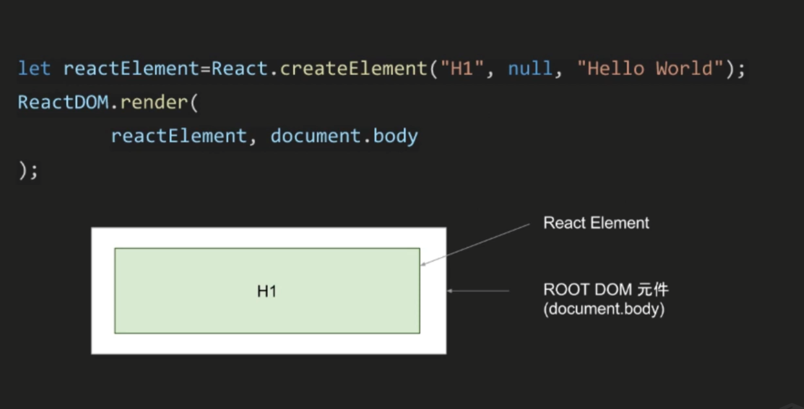

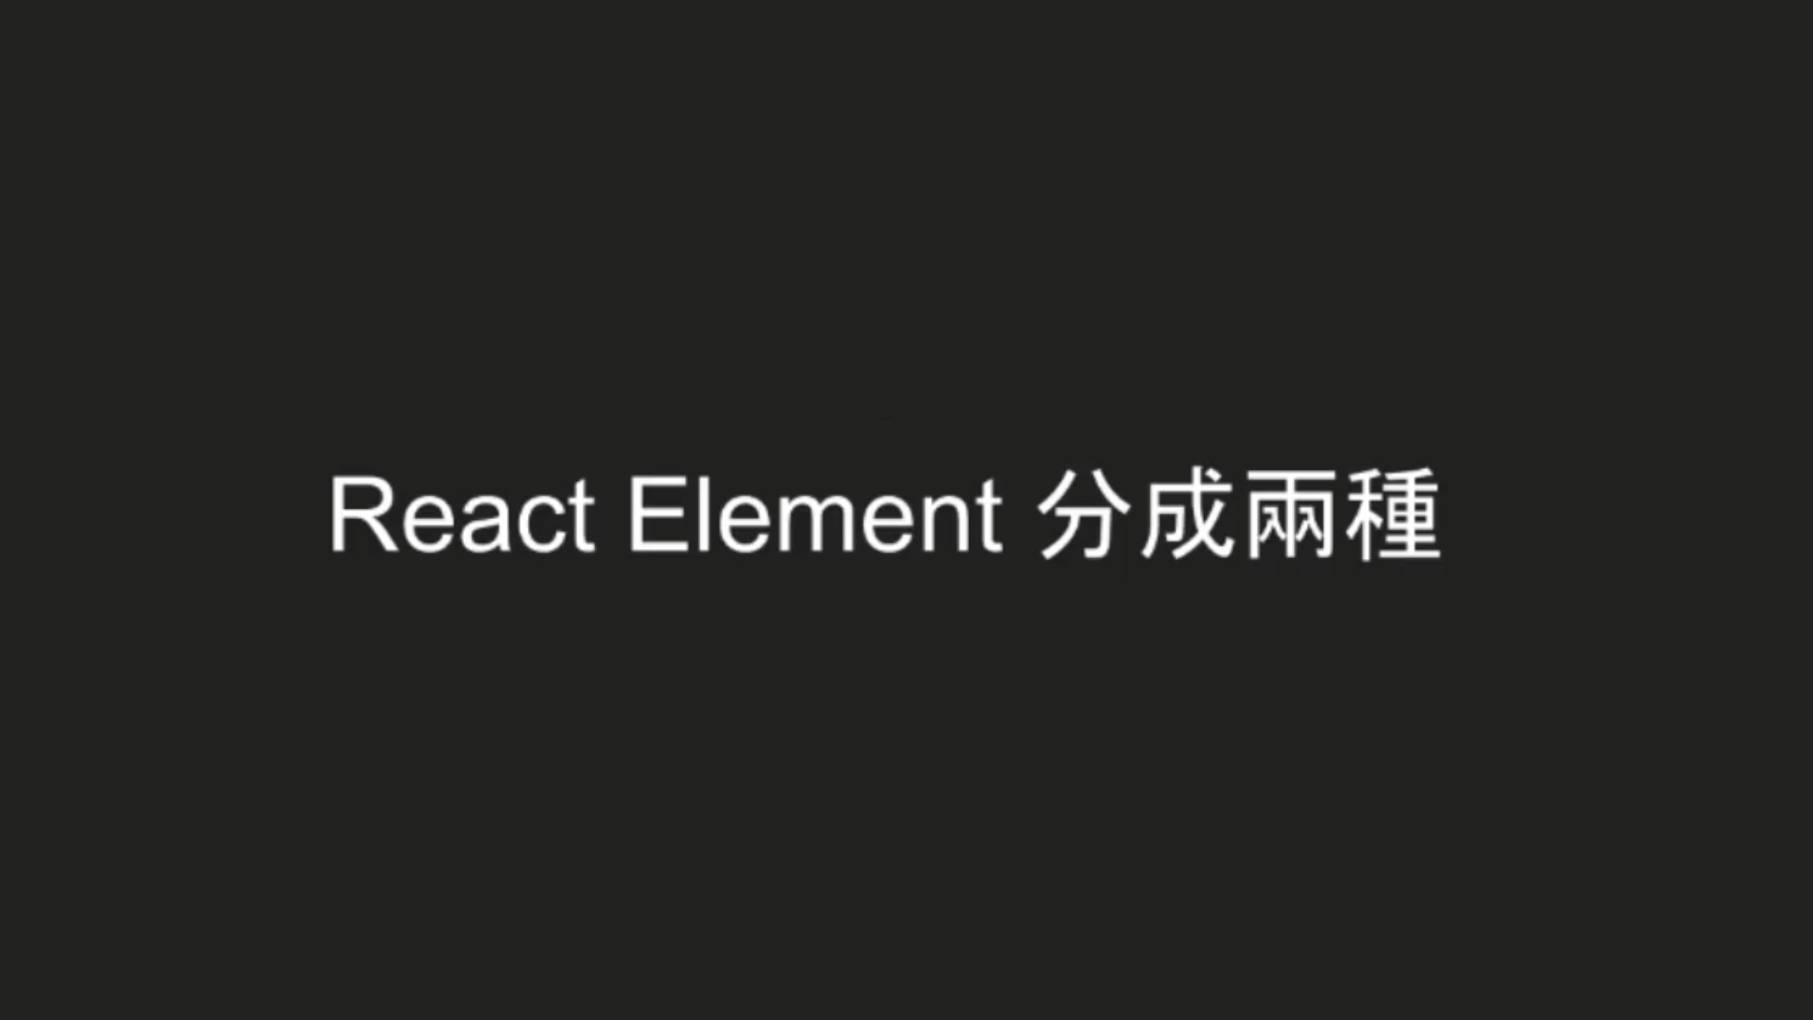

<h1> 就是屬於HTML DOM Element

